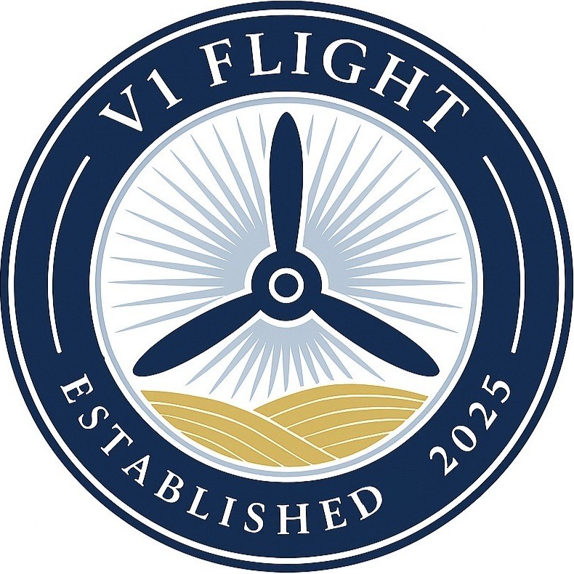
DISCOVERY FLIGHT EXPERIENCE
V1 Flight • Marion Airport (C17)
Take the controls of a real airplane with a Certified Flight Instructor during a 30‑minute introductory flight. Most people know right away whether pursuing a pilot certificate is the right path for them after experiencing a Discovery Flight.
What’s Included:
- 30-minute flight experience
- Opportunity to fly the aircraft
- Certified Flight Instructor
- One additional backseat passenger
- Aviation headset and all required equipment
What to Wear:
- Closed-toed shoes and comfortable clothing.
Payment:
- No payment is required when booking. Pay after your flight.
TO BOOK YOUR DISCOVERY FLIGHT
Call: (319) 261-9761
Email: taylor.v1flight@gmail.com
1690 Marion Airport Rd • Marion, IA 52302

